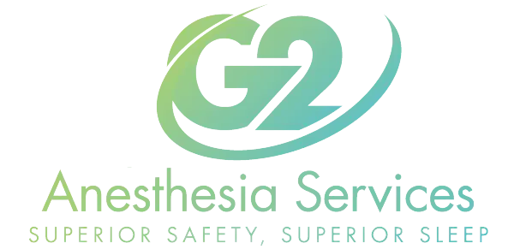

Marijuana and Smoking Protocols and Education
Smoking cigarettes, cigars, vaping, and or marijuana during the time leading up to your procedure have been proven to increase risks of negative outcomes during anesthesia-care. Because, of the increased risk of complications during anesthesia-care Lifeguard Anesthesia reserves the right to cancel your case on the day of service if you do not follow the following guidelines.
Cigarettes, cigars, vape- Abstain for 24 hours prior to scheduled procedure Marijuana- Abstain for 30 hours prior to your scheduled procedure
If you do not follow these guidelines you are at increased risk of myocardial infarction (MI)/heart attack, cardiac failure, respiratory failure, increased and excessive bleeding, and abnormal blood sugar levels. At Lifeguard Anesthesia our number one priority is your safety. We look forward to caring for you.
_________________________________________________________ Patient Signature

