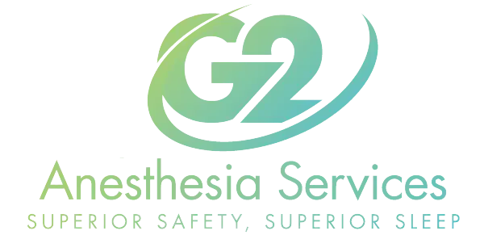

NPO GUIDELINES (Nothing by Mouth)
Lifeguard Anesthesia is primarily concerned with Patient-Safety. We always recommend that the safest and best practice is to have nothing to eat or drink 8 hours prior to procedure start time. However, for patients who feel they cannot fast for 8 hours, the following guidelines are the current recommendations and will be followed with absolute vigilance. Please note: Amounts of food or liquid taken by mouth are irrelevant, and are not considered when NPO Guidelines have been broken.
8 Hours- Any solid food containing fat
6 Hours- Any Solid food that is fat free. Also, any non-clear liquid or liquid containing fats and or acids. Examples Include (Coffee with cream, Orange Juice, smoothies)
2 Hours- Clear Liquids. Examples include (Black Coffee, Water, Gatorade)
I understand that avoiding food and liquids for 8 hours prior to my procedure is the safest way to put me to sleep.
Patient Signature_______________________________________

